 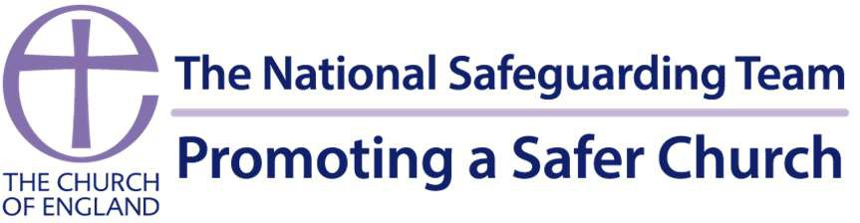

Question 1:

If your Church epitomised a healthy culture, what would you see, hear, feel, and experience as a member?

Question 2:

How could your church, its culture, and the way it is experienced contribute to the prevention of safeguarding issues?

Name:

Role:

Parish: