Church Name here
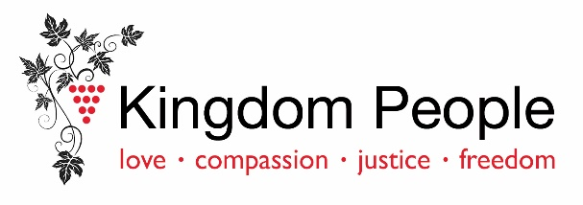
Health and Sustainability Plan

The diocesan vision: to grow as kingdom people, sharing the good news of Jesus’ love in Worcestershire and Dudley. As the body of Christ, we join together to worship, make disciples, share hope, and transform communities characterised by values of love, compassion, justice and freedom.

Our church’s vision:

Becoming a healthier church: (Our top three priority actions for the next 12 months)
Action Plan | Responsible | First step  (with date) | Next steps  (with dates) | Review by  (date)
Our first priority. If we could only do one thing, we would:
 | . | . | .
With God’s grace we hope this will:

This helps us: Worship God : Make Disciples: Share hope: Transform Communities:
Our second priority:
 | . | . | . | .
With God’s grace we hope this will:

This helps us: Worship God : Make Disciples: Share hope: Transform Communities:
Our third priority:
 | . | . | . | .
With God’s grace we hope this will:

This helps us: Worship God : Make Disciples: Share hope: Transform Communities:

Increasing our sustainability: (Our two priority actions for the next 12 months)
Action Plan | Responsible | First steps  (with date) | Next steps  (with dates) | Review by (date)
. | . | . | . | .
. | . | . | . | .

