Culture Conversation Audit
Please highlight whether you agree or disagree with the statements below. For example: Agree / Disagree / Not sure.

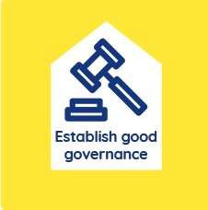 | Our procedures and the expectations on people are clear, consistent, and easy to understand. | Agree / Disagree / Not sure
 | Control within our church is not coercive, and the difference between demands and requests is clear. | Agree / Disagree / Not sure
 | When dealing with complex situations our church willingly seeks impartial advice from outside. | Agree / Disagree / Not sure
 | The behaviours shown by our leaders and others within our church are not rigid, dogmatic, or controlling. | Agree / Disagree / Not sure
 | People are given genuine freedom to make choices for themselves about matters that affect their lives. | Agree / Disagree / Not sure
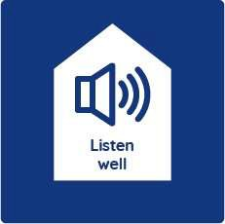 | Stories being told by people outside our church are mostly positive. | Agree / Disagree / Not sure
 | Stories being told by people inside our church are mostly positive. | Agree / Disagree / Not sure
 | I know what negative stories might be being told about our church. | Agree / Disagree / Not sure
 | Our church has a culture that welcomes feedback and encourages open discussion about these stories. | Agree / Disagree / Not sure
 | Our church has a culture that encourages us to be humble in the way we respond to issues and learn from them. | Agree / Disagree / Not sure
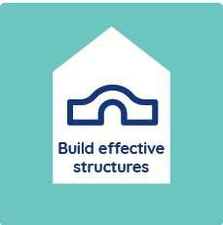 | The structures in our church help to develop and maintain safer, healthier cultures and practices. | Agree / Disagree / Not sure
 | I am clear about what our church is trying to achieve with its structure and that leadership is exercised safely. | Agree / Disagree / Not sure
 | Our leadership structure has processes in place that encourage and invite challenge, scrutiny and accountability.  The way our church’s structure works displays and develops safer, healthier culture. | Agree / Disagree / Not sure  Agree / Disagree / Not sure
 | Everyone with responsibility is offered an appropriate level of support e.g. through supervision, personal development,  coaching/mentoring, etc. | Agree / Disagree / Not sure

 | In our church decisions are made in a way that includes and welcomes the input of others. | Agree / Disagree / Not sure
 | Our leaders model humility and respect. They challenge any behaviours and attitudes which don’t value and treat people equally.  In our church I see people displaying safe and healthy attitudes, values, and behaviours. | Agree / Disagree / Not sure  Agree / Disagree / Not sure
 | In our church I can see where power dynamics could create unhelpful or harmful imbalances and I feel able to talk about this openly.  I feel I could challenge the development of authoritarian or dictatorial power dynamics in our church’s leadership. | Agree / Disagree / Not sure  Agree / Disagree / Not sure
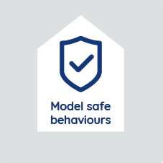 | Our church is committed to being transparent and clearly communicates what behaviours are acceptable and permissible.  Our church welcomes feedback on our practices and ways of working from people who are new. | Agree / Disagree / Not sure  Agree / Disagree / Not sure
 | Our church welcomes feedback on our practices and ways of working from people who are long-standing members. | Agree / Disagree / Not sure
 | Our routines and rituals are kept under review and reflect a safer, healthier culture. | Agree / Disagree / Not sure
 | Our routines and rituals take into account how they might affect people who may be vulnerable. | Agree / Disagree / Not sure
 | Our church communicates messages that support us to develop and maintain a safer culture. | Agree / Disagree / Not sure
 | Our church clearly communicates what a safe place looks like so everybody understands what’s expected of them and others.  A commitment to being a safer place is an important part of who we are as church. | Agree / Disagree / Not sure  Agree / Disagree / Not sure
 | I am clear about where accountability lies and that it is used to encourage personal value and equality? | Agree / Disagree / Not sure
 | Our church actively welcomes people who are broken, wounded and vulnerable providing them with a safe place. | Agree / Disagree / Not sure

Name:

Parish:

Role:

