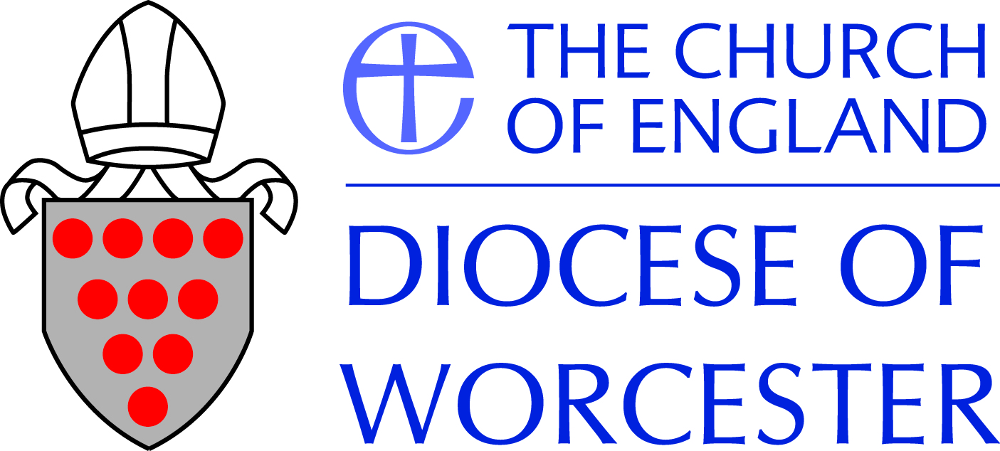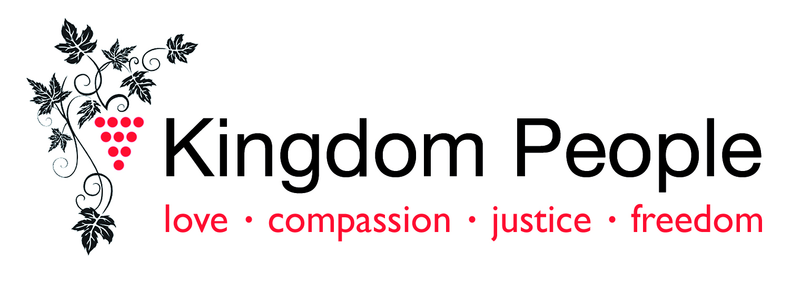

A Place to Belong: Access and Inclusion Guide
A guide to access, inclusion and welcome in our churches, especially in relation to people with disabilities, mental health challenges, or on the autism spectrum.

Introduction
We all want our churches to be places of welcome for all, and indeed we believe that church communities are only whole when they include everyone. However, there may well be barriers, visible or invisible, of which we are not aware, which are keeping people away from our churches. The worship, mission and buildings of our churches should enhance and enable a calling for all people, including and especially for people with disabilities, mental health challenges, and those on the autism spectrum, many of whom have experienced exclusion, in a variety of different ways. Remember that people with disabilities may be leaders or ministers in our churches. Whether or not you identify yourself as having a disability, don’t fall into the trap of thinking that disability access is about enabling “them” to “come in”. Disabled people are already here, and should have as much opportunity as others to develop in leadership and vocation.

What is this guide for?
It is intended to help you to ensure that your church buildings, worship, activities and people are as welcoming and inclusive as you would wish, to all in your local community, and in particular to people with disabilities. In order to play our part in the life of our church, we need to feel that we belong.

How does it work?
It takes you through the process of a disability access audit: looking at all aspects of your church building, worship and activities, to check how inclusive they already are, and if there are ways that you could improve them. It cannot possibly consider every detail of the great variety of churches, but hopefully will encourage you to think about some areas for disability inclusion that may not have occurred to you before.
The accompanying template is designed as a working tool to use as you meet to discuss your church – its activities and mission as well as the building itself. When it comes to measurements and specifications for buildings, please note that this guide does not attempt to include all the necessary detail. However, the information is readily available, and the resources listed at the end are the best starting point for these.
As you will probably know, if you are considering any new building work or refurbishment, you will need to consult your local Diocesan Advisory Committee, or equivalent, and obtain the necessary faculty before starting the work.

Churches and the Law: What do we need to know?
It is important to understand that all churches have responsibilities under the Equality Act 2010, which encompasses all the requirements of the earlier Disability Discrimination Act, and also introduces further duties in relation to disability discrimination. In terms of the legal framework, a church is considered to be a voluntary sector organisation, and a provider of services. Some churches may also be employers.
What are the key points in the Equality Act that we need to know?
- The definition of disability is much broader than we sometimes think. Disability is now defined as:
- “a physical or mental impairment that has a substantial and long term adverse effect on the ability to carry out normal day-to-day activities.”
- So, in addition to physical and sensory impairment, disability includes mental health issues and learning disability, as well as “hidden” disabilities such as epilepsy, diabetes, arthritis, autism, and various conditions which may cause chronic pain. So any church congregation is likely to have a considerable number of people living with disability, and we may not always be aware of it.
- Strong emphasis is given in the legislation to involving disabled people in consultations about changes or developments to buildings. As well as consulting with those in the congregation, invite the wider community to have their say.
- Churches are required to do all things reasonable to remove barriers to people with disabilities, or to provide services in a different way which makes them accessible, taking into account different needs. “Reasonable” is not defined in the legislation, but it is understood that a small village church with few resources would not be expected to have as much funding available as a large town centre church with more funds and more capacity to do the work of fundraising, planning and project managing refurbishment work etc.
- The legislation also requires us to be “anticipatory” – we need to think ahead about who might come to our church, whether for a service or as a visitor or tourist, and how the needs of our present congregation may develop in the future. This of course is also the message of the Gospel! 4
- The principle which the Equality Act upholds in relation to disability access is that it should be independent, where this is appropriate to the individual’s age. We like to be helpful and “help” a wheelchair user down the steps into church, but this should be avoided if at all possible; apart from being a safety risk to all involved, it can diminish the independence and dignity of the person.
- By working through this guide, you are fulfilling your legal duty to audit your church. You should report on what you find – what barriers you may have to disability access, and what reasonable adjustments you could make.
- You should record discussions and decisions in PCC minutes, to show that you are aware of your responsibilities and have taken all reasonable steps to meet them.
- We suggest that you consider what steps you can take in the near future to improve access (those that cost little or nothing); what you can plan for in the medium term, and what you might plan for in the longer term, for example if they require considerable fundraising.

How do people find your church?
You may well think that this is a strange question to ask, as of course you know where your church is, and you know how to get there. But for people with anxiety issues, or some people on the autistic spectrum, for example, it may not be so obvious. We all learn and take in information in different ways – some people prefer maps, others prefer descriptive directions, some people need directions with pictures or photos of the place they are trying to find.
If your church has a website, try to offer directions and location information in as many ways as possible. Please include information about public transport, where this is realistic, and also instructions about where to park, as some people need this information beforehand, rather than having to work it out when they arrive.

How do people get here?
It is important to bear in mind that many people with disabilities, including people with mental health problems, are among the poorest in our society. Many people with disabilities are reliant on benefits, and not everyone has a car. So it may be that some people with disabilities can only get to a Sunday service if they are near enough to walk or cycle, or a lift can be offered. Sunday mornings may also be a difficult time for people to get to church because of medication (which often takes effect later in the day) or caring responsibilities.
Most churches offer lifts to people who cannot get there otherwise. For those people in your community that you don’t yet know, but would like to reach, you may want to consider these factors.

Approach to the church building
If you have a gate at the start of a path leading up to your church, please consider how easy this is to open for people who may have painful conditions such as arthritis or Raynaud’s Syndrome (a very common condition which affects the circulation and can be very painful). Are you able to leave the gate open, safely? If you do need to keep it closed, please make the handle as easy to open as possible for a person with disabilities.
If you have a path up to your church, or through the churchyard etc. please consider how suitable the surface is for people with mobility impairment. Apart from the obvious trip hazard of broken or uneven paving slabs or stones, which are particularly difficult for people with visual impairment or walking difficulties, gravel is a real hindrance for wheelchair users. Hoggin or bonded gravel are better alternatives, as they give an even, textured surface.

Car parking
If you have a car park of reasonable size for your church, you should provide at least one disabled parking space. If you do not have a car park, but are aware that a disabled driver is coming to a service or event, you can create a temporary disabled parking space with bollards and a notice with the person’s name on it. However, do not leave this in the space, as it will be very awkward for the driver to park just outside the space, get their wheelchair out, move the bollard (which they may not be able to do), pack their wheelchair back in the car, park in the space, and then get out again. For details of the requirements and specifications for disabled parking spaces, see Come in! produced by Through the Roof (see below, Resources).

Signs and notice boards
Please consider how easily people who are driving or walking past your notice boards and other signage will see the information there, bearing in mind that they do not already know it. Thinking of people who have visual impairment, notices and signage need to be printed clearly with sharp colour contrast (black or a very dark colour on white or a very pale colour, or the reverse). The more concise you can make them, the less text you will need, and the clearer they will be. This is also helpful for people with learning disabilities, and for busy people who are rushing by, and who may not be able to give all your notices their full attention. If you publish phone numbers on your notice board, please include the area code for local numbers, not only for those using mobile phones, but in particular for Deaf people and those with hearing impairment, who are more likely to use texts rather than landlines.

Entrance
Believe it or not, you may need to make it really clear where the main entrance to your church is. People with anxiety issues or autism spectrum disorder (ASD) may need especially clear signage to indicate which door you expect them to use. Ideally, the main entrance will be the same one for everyone, but if you have to ask wheelchair users to use a different one, because of level access, it is most important that this is clearly signed.
If you are not able to offer a level entrance into your church at the moment, please make sure that any ramp in place over steps is safe and also legal. The maximum permissible gradient is 1:12 (the preferred is 1:20), so for each 1” of the step you will need 1’ in length of the ramp. Please bear in mind that anything steeper than this is illegal and probably also dangerous. Ramps need to be made safe with handrails and adequate turning space, and thought needs to be given to the direction in which doors open.
Whilst level or ramped access is necessary for wheelchair users, most other people, particularly those who walk with sticks or frames etc. feel safer with steps, and so it is important to have adequate width space, with handrails, beside the ramp, for people to walk safely.
All steps, changes of level and edges of ramps must be clearly painted, taped or otherwise marked with a strongly contrasting colour or design. The contrast marking needs to be on both horizontal and vertical edges of steps. This applies both outside and inside buildings, and is for the particular benefit of people who are blind or partially sighted. Sometimes there is a natural contrast of different materials, for example pale stonework against dark floor tiles.
If you have glass doors at the entrance to your church (or indeed inside) it is vital that these have “manifestation” which helps to make them visible, again in particular for people who are blind or partially sighted. There should also be high-contrast marking all around the door(s) to distinguish from the surrounding. Again, please refer to Through the Roof’s Come in! for details and specifications.

Lighting
Good lighting is of course important for everyone, but especially for those who are blind or have visual impairment, and also for people with hearing impairment. Lighting levels need to be even and constant throughout the building, rather than variable.
All of us rely to some extent on lip reading when we are listening to people, whether or not we are aware of it. For people with hearing impairment or people who are Deaf, lip reading can be an important part of their communication. Good lighting assists greatly with this, and it is important that the whole face of the person speaking can be seen clearly, in good, even light. It is also important to ensure that people who are reading / speaking / leading worship are not standing with their back to the light, as this makes it difficult to see the face and lips clearly, as they will be in shadow. A person who is lip reading will need to be quite close to the speaker, even with good lighting, so please bear in mind that if the person leading worship moves a distance (e.g. going up to the sanctuary at the start of the Eucharistic prayer) this connection may be lost.
We also need to bear in mind that not all people who are Deaf or deafened can lip read, and that even where people have learnt this skill, it is estimated that only about one third of words in the English language are “readable” by people with reduced or no hearing. Therefore, every possible assistance should be given for those who are Deaf or hard of hearing.
If you are considering a special service with low levels of lighting, for example a candlelit carol service at Christmas, please consider what effect this will have for people who are partially sighted. For example, ensure that instructions about the service are given beforehand in good lighting.

Hearing loops
Hearing loops are very helpful for people who rely on hearing aids. If you have a hearing loop in your church, it is important to check regularly that it is working well (and you have spare batteries), and it is most important that everyone who is speaking uses the microphones that are linked to it. Please don’t let anyone say “I can project my voice and so I don’t need a microphone” as this may help some people, but it doesn’t help those who tune in to the loop.
If the loop or microphones are not working properly, those people who use hearing aids will quickly lose out on what is being said, and soon feel excluded. If you do not have a hearing loop in your church, please consider having one installed.

Communication needs of Deaf and deafened people
Some Deaf people use British Sign Language (BSL) and may need you to provide a BSL/English interpreter to enable them to access your church. This may be because they want to come regularly, or because they are attending an event at the church such as a wedding or a funeral. Church members may also like to learn some basic BSL to help them to be able to talk to Deaf people and welcome them to the church. You can find more information about including Deaf people who use BSL in the life of the church from the “Sign Me In!” policy you can find here: http://www.gosign.org.uk/publications
Not all Deaf people use BSL. People who are Deaf or deafened (i.e. who have lost hearing gradually over the years) or hard of hearing have a range of communication needs, and a variety of strategies to aid any residual hearing and to communicate with others. These are very individual, so remember to ask people with hearing impairment what helps them in particular.

Moving around inside the church
Please consider how easy it is for people, especially those with mobility impairment or visual impairment, to move around to different parts of the church, bearing in mind that people with disabilities are leaders as well as participants. Very often we find that there is level access as far as the chancel step, and often it is assumed that those who cannot walk or wheel up to the altar (assuming a high altar) are happy to receive Communion in their place. It’s always worth checking this, just in case there may be an alternative that could be offered.
Please be aware that some people need to be able to move around in church, including going outside and possibly coming in again, in order to relieve stress.

Seating
Whether your church has pews or chairs, you should consider what the seating is like for people living with physical pain conditions, and also for wheelchair users. People who live with chronic pain, a very common hidden disability, often find pews uncomfortable, and difficult to sit in for any length of time. Is it possible to provide some more comfortable chairs – with arms, as many people find they need these to push themselves up – in some areas of the building? Do wheelchair users have the same choice of where they can sit in church as everyone else? They may not find it very welcoming if they have to sit at the very front or the very back of the congregation.
Whilst we recognise that there are important theological or liturgical reasons why we reorder our churches, it is important too that we consider the comfort needs of all those in our communities. And, in considering those with mental health challenges: when unwell, some people prefer to sit alone, whilst others prefer to have company. Some people may become restless, for a variety of reasons. It is important to understand why someone is behaving in the way they are, and not to expect everyone to do the same thing. This requires everyone to show tolerance whilst recognising the impact some behaviour such as shouting can have on others in the congregation. We often joke that people in churches always sit in the same place, and consider particular seats to be “theirs”. Whilst it’s great to encourage flexibility in this regard, remember that some people, particularly those on the autism spectrum, may need to have this kind of routine, and making light of it can make them feel stressed or even unsafe.

Orders of service, notice sheets, hymn books and screens
Please consider how accessible these are for people with different disabilities, and in particular for people with visual impairment; people with learning disabilities, and people with specific learning difficulties or dyslexia.
- Clear print guidelines require a minimum font size of 12 point, where a clear sans serif font is used (such as Arial, Franklin Gothic, Verdana, Lucida Sans.)
- Print should be clear and sharp, in a strong dark colour (ideally black) on a white or very pale coloured background.
- Many people with dyslexia find it easier to process information where there is a pale coloured background, rather than white. Paper should be matt rather than gloss, and if double-sided printing is used, the paper needs to be weighty enough that the print does not show through.
- Where photos or pictures are used, captions should be printed above or below, not on top of, the picture.
- A small number of large print copies of the same print materials should be available at every service, for people with visual impairment. This requires a minimum font size of 18 point.
- Where screens are used in worship, it is good practice to provide a small number of printed copies of the service, in particular for those who find it difficult to look at the screens because of physical conditions, and for those who need to see the whole service before it starts, so that they know what is going to happen. (Or you may need to provide this information in some other way, for example for people on the autistic spectrum.)
- Remember that the principles of clear print also apply to websites.

Toilets
If you are considering installing toilets in your church, it is a legal requirement to provide at least one accessible toilet. You need to take great care that the toilet meets all the current building requirements (Part M). As well as the dimensions and specifications, it is most important that the final details are accessible for people with mobility or visual impairment: that taps are easy to turn; that there are the requisite colour contrasts throughout; that mirrors etc. are placed at the right height, and that the emergency alarm cord is in place with the right fittings, and that you have a procedure for responding if it is used. See Come in! or Widening the eye of the needle for details.

If you do not have any toilets at all in your church there is currently no legal requirement to provide one, and indeed those churches which have an arrangement with a local hall or pub to use their toilets are probably providing a reasonable degree of access for everyone, including people with impairment.

If you currently have toilets at your church, but no accessible ones, you should consider how you might be able to provide one, allowing for cost, space, faculty etc. Although there are no longer “grants for disabled facilities”, it may well be possible to obtain a grant from Awards for All (National Lottery) or other similar small grant organisations, if it is part of a wider project which will improve community access to your church.

Welcome for people with learning disabilities
Our welcome for people who have learning disabilities, autism or mental health needs is as important as making our church buildings accessible for people with physical or sensory impairment.
There are many ways in which we can make our worship and church life more welcoming and inclusive for people with learning disabilities:

- using drama, pictures and simple language in worship;
- giving a summary of the main points of talks or sermons;
- appointing a suitable person or small team to befriend individuals with learning disabilities, and make sure they understand what is going on.

People with learning disabilities often say that they are not included in things like coffee after the service, social activities and events during the week, and so it is worth giving some thought as to how you can do this in your church. See Opening the Doors (below, Resources) for more ideas.

Welcome for people with autism
Similarly, we need to give thought to how we welcome people with autism, or on the autism spectrum. In order to do this we need to understand the particular needs which autistic people may have, also bearing in mind that each individual’s needs, gifts and abilities will vary widely. See Welcoming Autistic People in our Churches and Communities and also Through the Roof’s “A Welcoming Place: Autistic Young People in Church (below, Resources) for more ideas.

Welcome for people with mental health challenges
People with mental health challenges often report that they find churches to be places of acceptance and valuing, where they feel safe and where they can belong. Sadly many have also had bad experiences of church, particularly where they have felt judged by others for their illness. Sometimes they have been told that they must have unconfessed sin, a lack of faith or prayerfulness to account for their difficulties, although the same comments are rarely made of physical ill health. If we avoid people when they are unwell for fear of saying the wrong thing, this usually makes the situation worse, as it can reinforce the person’s negative image of themselves and their sense of shame. It is fine to talk about neutral subjects or to ask anyone how they are.

Asking questions is a good way of expressing interest as well as gaining understanding. Each person’s response to their illness can be very different. As mental health problems are often invisible, if mental health is not openly discussed at the front of church it may convey the impression that such problems are shameful, and so reinforce the stigma associated with them. Sharing testimonies is particularly helpful and it is important to ensure that intercessions include those with mental health problems as well as physical illness or disability.

In terms of participation in church life, mental health challenges should not prevent an individual from being able to contribute to the life of the church, if they wish, which will benefit both the church and the person concerned. For most people, mental illness fluctuates, and so their involvement may be variable. It is helpful if the church community recognises and accepts this fluctuation.

Recent years have brought considerable interest in the spirituality of people with mental health needs, and work has been done on “person centred churches”, finding that such communities accept people for who they are; really allow true differences of opinion; stay in touch with people if they are not well; meet needs with practical approaches; are prepared to learn what is appropriate and to abandon what is not, and are not too preoccupied with their own agenda.

This same work has found that the particular positives in church communities which people with mental health needs value are:
- kind people;
- music and art;
- an accepting spirit;
- social contact;
- being welcomed;
- reflection encouraged;
- a calm influence,
- and freedom to be oneself.

See The Mental Health Access Pack, which has lots of useful information to help parishes towards a better understanding of mental health issues.

Welcome, worship and nurture for children with additional needs
All that has been said above applies of course to work with children and young people with additional needs. Families of children with learning disabilities or on the autistic spectrum report that they appreciate churches which accept their child as she or he is, and also ask parents and carers what is most helpful for them.

Please remember that for any work you propose to carry out on or around your church building, you should consult your church architect and the Diocesan Advisory Committee (DAC) at the earliest possible opportunity.

Resources
Churchcare’s Guidance Note: “Accessibility and Disabled People” provides a useful summary of the legal requirements, and carrying out an Access Appraisal and Plan. www.churchcare.co.uk/images/access_and_disabled_people.pdf.

Livability is a Christian disability charity that supports people to connect to their communities. It provides information, resources and training. www.livability.org.uk
Opening the Doors: ministry with people with learning disabilities and people on the autistic spectrum. Archbishops’ Council, 2009

The Mental Health Access Pack www.mentalhealthaccesspack.org/

Special Children, Special Needs: integrating Children with Disabilities and Special Needs into Your Church. Simon Bass, 2003

Through the Roof for resources, especially practical details: www.throughtheroof.org
The booklet Come in! has all the details (measurements etc.) for physical access to buildings.

A Welcoming Place: Autistic Young People in Church is a useful practical guide to including children and young people on the autism spectrum in church life.

Torch Trust for the Blind shows how churches can be more accessible to people who are blind or visually impaired. A church pack can be obtained by registering on the website: www.torchtrust.org

Welcoming Autistic People in our Churches and Communities https://www.oxford.anglican.org/wpcontent/uploads/2013/01/autism_guidelines.pdf

Widening the eye of the needle: access to church buildings for people with disabilities. John Penton. 3rd edition 2008, Church House Publishing

March 2019
For further help or information on any of the above issues, please contact:

Jo Hyrons
Diocesan Disability Advisor
01905 732818
j.hyrons@cofe-worcester.org.uk

A note about language
Our language is changing all the time, and none more so than that around disability and mental health. For example, some people are proud to call themselves disabled; others prefer to use the phrase “person with a disability or disabling condition”, and many people who are disabled according to the legal definition do not identify themselves in this way.
Some people say that we are all disabled or have special needs to some extent, but to some disabled people this is offensive. Most people would agree that those who consider themselves to be “able-bodied” or not disabled, are only temporarily so, as most people develop impairments as they grow older.
The language around mental health is yet more complex – should we say “mentally ill”, to show that we understand that it is an illness, or “mental distress” - or avoid the word “mental” altogether, with its negative associations?
The language of disability and of mental health has been used over the years to discriminate, harass and abuse people, and we are right to be careful in our choices. When we get to know people, however, we tend not to need to use any of these phrases, and we just use the person’s name.
In this document, we alternate between the first and the third person, as we recognise that those with disabilities or mental health challenges or an autistic spectrum condition may be “we” or “they”. Similarly, in recent years there have been a number of different words which have sought to express the idea that everyone should have equal access to all areas of life and society, including church. Words such as access, inclusion, participation, welcome and respect are just some of these, and all have their own associations.
Here we have chosen “belong” to encompass the idea of being a part of a church or group or fellowship, where we can each play our own part; be valued and accepted for who and what we are, and find our own vocation or ministry. Of course in order for all this to happen, we need to be able to get in to the building (usually); to hear, see and understand what is going on, and to take a full part in all the activities.

