Admitting Children to Holy Communion before Confirmation

Resource Pack

Diocese of Worcester

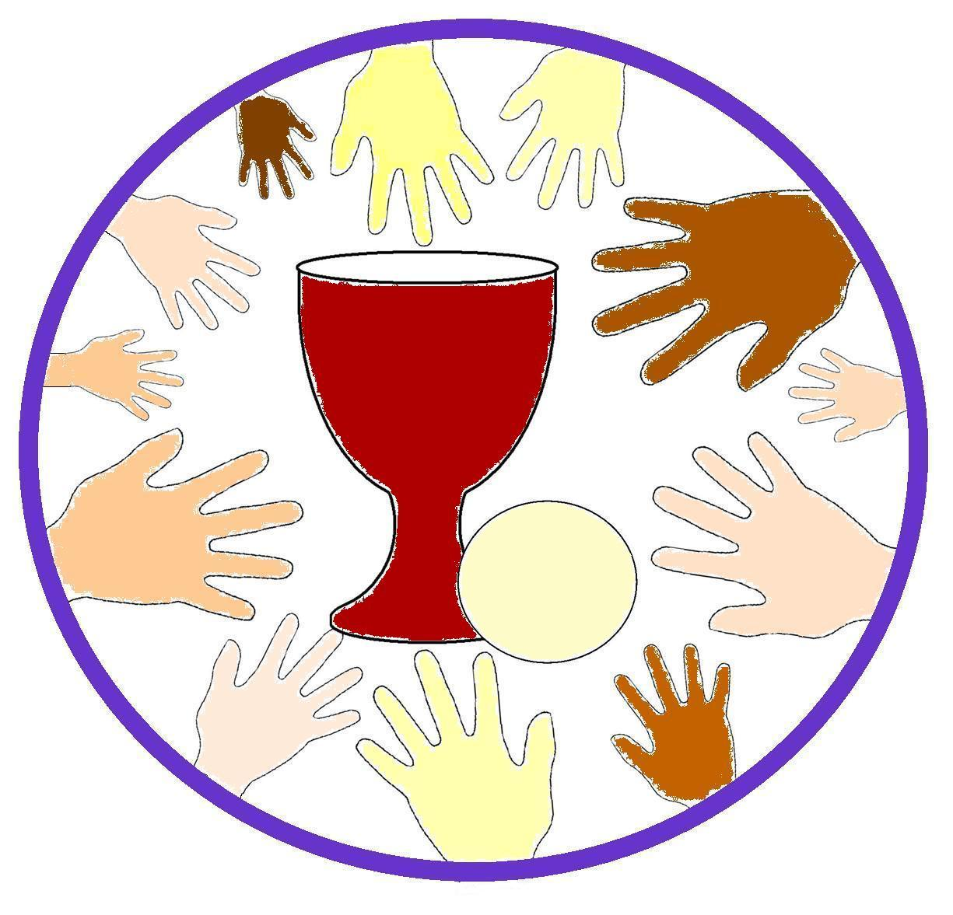


Contents
- What Do Children Think?
- Reflections on Children & Holy Communion
- Frequently Asked Questions
- Checklist
- Directions of the Bishop of Worcester
- New Regulations – General Synod
- Four week course for Children on Eucharist
- Resources
- Blank Application Form
- Blank Certificate

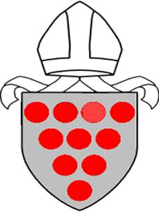
What Do Children Think?
There are lots of things I don’t understand yet. But my family still feed me.

‘I like being apart of carrying the bread or wine up to the front, but why can’t I take it?’

I love Jesus just as much as everyone else!

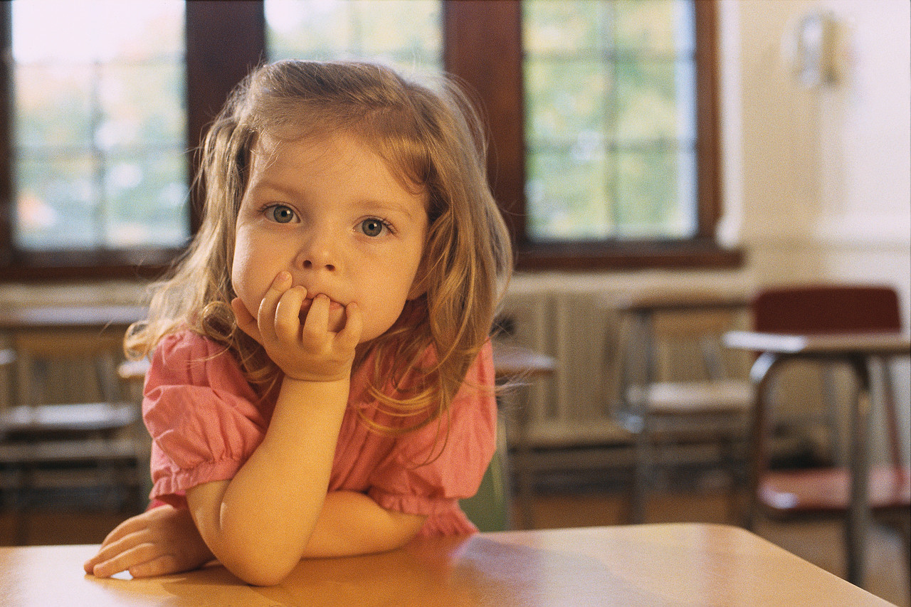

Why does the vicar say we are one body because we all share one bread, when I don’t get any?
I think if I had been in that room with Jesus and the disciples, and I was hungry, Jesus would have given me something to eat and drink the same as the others.

Some answers children have given.

Question : What do you think about when you have the bread and wine?
Answer : Being at the Last Supper with Jesus and His friends. It’s like being one of them.

Question : Why do you think Jesus wants us to share bread and wine?
Answer : To show what He did for us and So that he can be really near us.

Question : Does the communion part of the service feel different?
Answer : Everyone joins in and feels special.

Question : What do you like about the Communion part of the service?
Answer : When the Vicar blesses the bread and wine and prays blessing on those who don’t take bread and wine.

Question : What do you like about having Communion?
Answer : it’s great sharing the experience with other people.

Reflections on Children and Holy Communion

We hope this pack of information will help you explore the opportunities offered when considering the admission of children to Holy Communion before Confirmation.

The History

The practice of the earliest Christians with regard to receiving Holy Communion is not clear but certainly whole households were baptised and it is assumed that children would have been included. It seems that Communion immediately followed Baptism, and there is no indication that children were excluded. The Eastern Orthodox Churches have always communicated children immediately after Baptism.

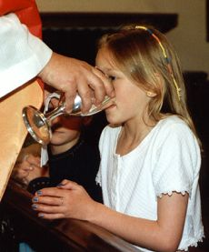
The subsequent divorce of Communion from Baptism has been the combined result of the theological preoccupations and practical circumstances of following centuries: e.g. the doctrine of original sin led to the promotion of infant Baptism; church expansion necessitated Baptism by priests rather than bishops, followed by laying on of hands by bishops during periodic tours; the failure of parishioners to present children to the bishop on these occasions contributed to the bishops demand that laying on of hands precede Communion; the development of laying on of hands into a rite involving the confirmation of baptismal vows produced an emphasis on the need for teaching before Confirmation.

The moves in recent times from afternoon to morning meetings of Sunday School, and towards Parish Communion as the regular Sunday service have led to a new practical situation in which children find themselves regularly in church at a service in which they cannot fully participate.

The tradition of the church regarding admission of children to Communion is not represented by a static norm but is characterised by a continued development in practice in the light of changing situations: in the spirit of this tradition, what developments are appropriate to our situation today?

Seeing it from the Child’s View


Child psychologists and experts in children’s spiritual development alike point to the importance of children taking part in practical activities learning by doing and of their natural facility for engaging with symbol and mystery. Full participation in Communion is sometimes claimed to be an erosion of childhood, but instead it could be seen as cherishing and making best use of the very characteristics of childhood.

One important characteristic of childhood is the need to belong. Partaking in Holy Communion is a powerful indication of belonging to God, and to one another in the Church. Much is made of what children may or may not understand about the sacrament, but they will certainly understand the rejection implied in being denied food at the Lord’s Table.

Frequently Asked Questions
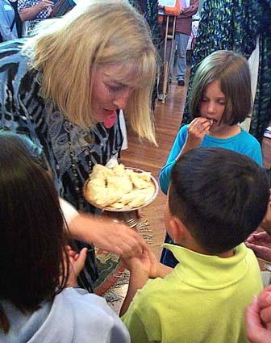
Will the children understand what they are doing when they take Communion?
Children are certainly able to understand the origin and specialness of sharing the bread and wine. A deeper understanding of the mystery of the sacrament is a lifetime s work for all of us, and one that will never be complete however old we are. The important point to consider is whether we ought to view taking Communion as a prize which we win by passing tests, or whether we should see it as a free, gracious and unconditional gift from God.

Will they take it seriously?
Children respond to the mood and atmosphere around them. The vast majority of children will take their lead from the way the adult members of the congregation behave as they receive the bread and wine. Receiving Communion is a very powerful moment, and the power is certainly not lost on children in fact they have an openness to the Holy which many adults find it hard to recapture.
How will the vicar know who can receive?
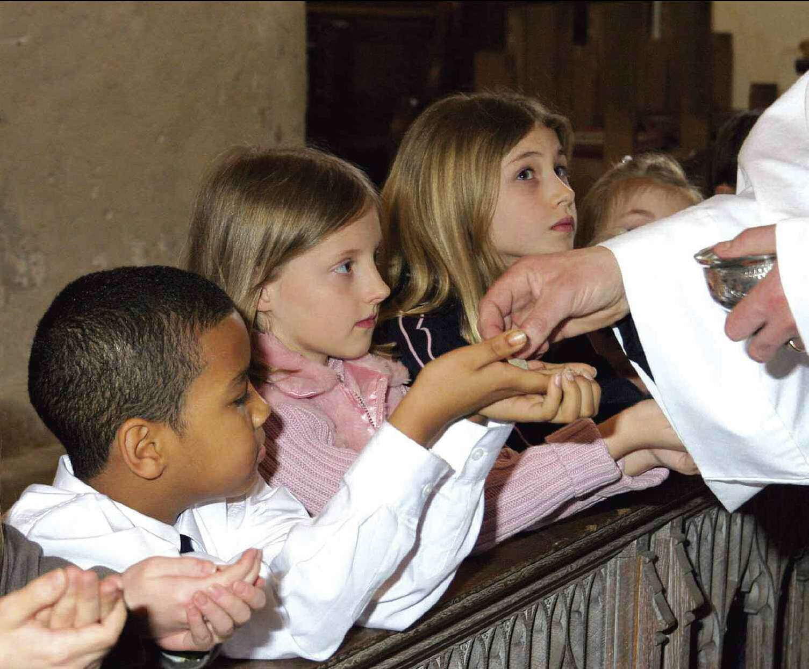
A record must be kept of all the children who have been admitted to Communion before Confirmation, and the parish clergy will have been involved in preparing the children for admission. There should not, therefore, be a difficulty in knowing which children should receive.
What happens if a family moves to a parish which doesn’t admit?
When the admission of children to Communion before Confirmation was first introduced, a major concern was that there would be problems if a child who had been admitted moved to a parish that didn’t admit. In practice, this has not proved to be a difficulty: the incumbent of the parish in which the child has been admitted simply provides a letter to their new incumbent requesting that they continue to receive Communion. The principle, supported by the House of Bishops, is that no one who has been admitted to receiving the sacrament should ever subsequently be denied it.
What about children who are not baptised?
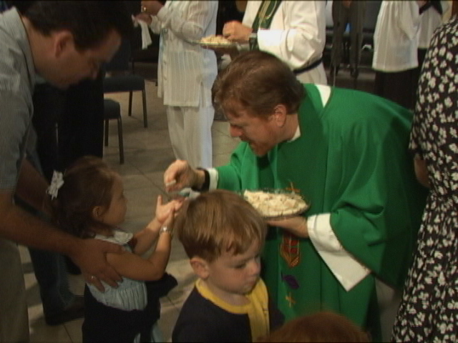
No one who is not baptised can be admitted to receive Holy Communion. If an unbaptised child wishes to be prepared for admission then they must be baptised before they are admitted. Their Baptism could form part of the preparation programme. However, it is important to consult fully with the family beforehand to make sure that they are willing for the Baptism to take place.

What if children do not want to be admitted to Communion before confirmation?
Consent is vital at all levels in admitting children to Communion. No one must feel that they are being forced into the practice. The parish as a whole must be supportive, and so must any family whose children are going to be involved. But most important, the individual children must make a free choice to be admitted. It may well be that some children in a particular church ask to be prepared for admission, and some do not.

What happens if not all agree to the change?
It is rare to have complete agreement on any development in the Church or any other large organisation for that matter. It is not necessary to have 100% agreement in the parish for admission to go ahead; however, there should be substantial support. Admission should not be a practice that disappears from the life of a parish if the vicar or a few enthusiastic families move elsewhere.

Checklist
 | Process |  | Notes
1 | Read through the Bishop of Worcester’s Regulations and Guidance notes enclosed in this pack. | ◻ | Make reference to General Synod’s regulations. Please note;  - Children already receiving Holy Communion and remaining in good standing with the church will continue to be able to receive Holy Communion.  - The previous Guidelines have now been superseded by the Regulations. All parishes who wish to use this opportunity must apply under the terms of the Regulations. Parishes which have such policies in place must now complete the forms and return them to the Bishop.  - Communion before Confirmation does not replace Confirmation. The Bishop expects that children who have been admitted to Holy Communion will, in due season and at the appropriate time in their development in Christian faith, be brought to him for Confirmation.  - No person may be admitted to Holy Communion who has not been baptised  - The person who has parental responsibility for the child has to be content that their child may be admitted to Holy Communion
2 | Open the discussion with the PCC | ◻ | It may be helpful if you undertake some initial research referring to how other parishes and other denominations have approached this issue. It may also help to contact the Diocesan Children’s Officer.
3 | Consult with the congregation | ◻ | Perhaps through an open meeting (possible use of the Power point may help these discussions).
4 | After further discussion, PCC makes a decision as to whether to proceed further | ◻ | If the PCC decide to proceed (a resolution should be passed) then continue with the checklist below. If the PCC decide not to proceed then careful thought and prayer is needed when feeding the decision back to the congregation and when informing parents and children who are most likely to be affected.  A review date should be set (no more than 5 years)
5 | Feedback the decision to the congregation | ◻
6 | If proceeding, consult with children’s leaders about a preparation programme | ◻
7 | Identify leaders for the preparation course & materials to be used for preparation | ◻ | See the list attached to this sheet for a range of resources or use the 4 week preparation course attached
8 | Identify the means by which you will provide continuing nurture for those receiving Holy Communion. | ◻ | This would normally be done through the usual programme of activities for children and youth.
9 | Consider the implications for the pattern of services, liturgy and participation of all ages | ◻ | Those receiving communion may have a separate Liturgy of the Word but all should be present in the main assembly for at least the Eucharistic Prayer.
10 | Complete the application form which outlines the process to be followed and the pattern of preparation and continuing nurture which must be followed. | ◻ | Send one copy of the application form to the Diocesan Children’s Officer.
11 | Bishop of Worcester will send a letter to you giving permission for the admission of Children to Communion before Confirmation. | ◻
12 | Communicate the arrangements to the congregation | ◻
13 | In consultation with parents and children’s leaders, invite children to consider receiving communion | ◻ | This should be done with sensitivity. Some parishes have found it helpful to get written permission from parents.
14 | Deliver the preparation course, involving parents where appropriate | ◻ | See resources sheet or course.
15 | Arrange the service at which children will receive Holy Communion for the first time | ◻ | It is anticipated that this service would become a regular event.
16 | Record the names of children admitted to communion in an Admission to Communion Register | ◻ | At present there is no dedicated Admission to Communion Register. We recommend you purchase a good quality general register and adapt it so that names, dates and officiants could be recorded.

- You would need to write letters of commendation for any children moving to a new parish.
- These procedures should be reviewed regularly.


Admitting Children to Holy Communion before Confirmation

Directions of the Bishop of Worcester

The New Regulations
The General Synod has agreed new regulations for the admission of children to Holy Communion before Confirmation. They are attached to these directions and must be adhered to in the diocese.

Under the regulations the Bishop has power to issue directions. These now replace previous Guidelines.

There are two important preliminary points that we all need to understand.

- Children already receiving Holy Communion and remaining in good standing with the church should not be deprived of the sacrament and will continue to be able to receive Holy Communion

- All previous Guidelines have now been superseded by the Regulations. All parishes who do not already commit children to Holy Communion but want to do so must apply under the terms of the Regulations.

Children and Holy Communion in the Diocese
Parishes should be encouraged to consider the opportunities this ministry affords to them for strengthening our ministry to children and to their families. Every parish needs to have a clear strategy for its ministry among children. The Gospels record Jesus’ welcome to children and his encouragement to them to come to him. The Church needs to reflect this Gospel imperative.

In the Diocese of Worcester parishes seeking to take advantage of these provisions will need to have consulted with the Diocesan Children’s Officer. In the light of their comments and encouragement the Bishop will give the necessary permission.

Parishes where children already receive Holy Communion before Confirmation
The Regulations require these parishes to submit a fresh application. You may consider this an opportunity to refresh the parish policy for this ministry. A copy of the resolution taken by the PCC, copied to the bishop, and to the Children’s Officer, will be all that is needed.

Children already receiving the Sacrament must continue to be able to benefit from it whilst they remain in good standing with the church.

Parishes who wish to bring children to Holy Communion before Confirmation that have not previously done so.
The Regulations make two things clear:-
- No person may be admitted to Holy Communion who has not been baptised
- The person who has parental responsibility for the child has to be content that their child may be admitted to Holy Communion

Communion before Confirmation does not replace Confirmation. The Bishop expects that children who have been admitted to Holy Communion will, at the appropriate time in their development in Christian faith, be brought to him for Confirmation.

Before the Bishop gives permission for this ministry to take place in the parish the following steps are essential for the application to succeed:

- The parish has prepared a programme of teaching, leading to the PCC passing a clear resolution in support of this ministry in the parish
- A programme must be set up for implementing this policy. This must include the preparation of the children, the gaining of the consent of their parents, the training of all who administer the Sacrament, a programme for preparing people for confirmation and a timetable including a proper welcome service and occasion for those to be admitted.
- Evidence that the parish has taken time to consult the Diocesan Children’s Officer who can assist in setting up programmes for this ministry
- The application should then be completed and sent to the Diocesan Children’s Officer.

The Bishop will issue permission when he is satisfied that the Diocesan Children’s Officer is content with the work done in preparation by the parish.

Some general guidance on the way
- This is an opportunity for the parish to consider all its work with children and young people.
- It is also an opportunity for an inclusive approach to families
- No age limit is being set but you do need to be satisfied that the child is able to understand what is happening and has been duly prepared. The age of six has often been considered a good guiding age for this ministry to begin.
- As the child grows into adulthood and continues in the journey of faith he/she will need to be brought to confirmation. It may help to see confirmation as part of the process of the outworking of baptism, so that the whole ministry is firmly rooted in the Church’s baptismal discipline.

Attached to these directions are the Regulations, a copy of the Application Form outlining the procedure.

ADMISSION OF BAPTISED CHILDREN TO HOLY COMMUNION REGULATIONS 2006

The General Synod hereby makes the following Regulations under paragraph 1(c) of Canon B15A :-

- These Regulations may be cited as the Admission of Baptised Children to Holy Communion Regulations 2006 and shall come into force on such day as the Archbishops of Canterbury and York may jointly appoint.

- Children who have been baptised but who have not yet been confirmed and who are not yet ready and desirous to be confirmed as required by paragraph 1(a) of Canon B15A may be admitted to Holy Communion provided that the conditions set out in these Regulations are satisfied.

- Every diocesan bishop may at any time make a direction to the effect that applications from parishes under these Regulations may be made in his diocese. The bishop’s discretion in this respect shall be absolute, and he may at any time revoke such a direction (without prejudice to the validity of any permissions already granted thereunder).

- Where a direction under paragraph 3 is in force in a diocese, an incumbent may apply to the bishop for permission that children falling within the definition in paragraph 2 may be admitted to Holy Communion in one or more of the parishes in the incumbent’s charge. Such application must be made in writing and must be accompanied by a copy of a resolution in support of the application passed by the parochial church council of each parish in respect of which the application is made.

- Before granting any permission under paragraph 4, the bishop must first satisfy himself (a) that the parish concerned has made adequate provision for preparation and continuing nurture in the Christian life and will encourage any child admitted to Holy Communion under these Regulations to be confirmed at the appropriate time and (b) where the parish concerned is within the area of a local ecumenical project established under Canon B 44, that the other participating Churches have been consulted.

- The bishop’s decision in relation to any application under paragraph 4 shall be final, but a refusal shall not prevent a further application being made on behalf of the parish concerned, provided that at least one year has elapsed since the most recent previous application was refused.

- Any permission granted under paragraph 4 shall remain in force unless and until revoked by the bishop. The bishop must revoke such permission upon receipt of an application for the purpose made by the incumbent. Such application must be made in writing and accompanied by a copy of a resolution in support of the application passed by the parochial church council of each parish in respect of which the application is made. Otherwise, the bishop may only revoke a permission granted under paragraph 4 if he considers that the conditions specified in paragraph 5 are no longer being satisfactorily discharged. Before revoking any permission on these grounds, the bishop shall first notify the incumbent of his concerns in writing and shall afford the incumbent a reasonable time to respond and, where appropriate, to take remedial action.

- Where a permission granted under paragraph 4 is in force, the incumbent shall not admit any child to Holy Communion unless he or she is satisfied that (a) the child has been baptised and (b) a person having parental responsibility for the child is content that the child should be so admitted. Otherwise, subject to any direction of the bishop, it is within the incumbent’s absolute discretion to decide whether, and if so when, any child should first be admitted to Holy Communion.

- The incumbent shall maintain a register of all children admitted to Holy Communion under these Regulations, and where practicable will record on the child’s baptismal certificate the date and place of the child’s first admission. If the baptismal certificate is not available, the incumbent shall present the child with a separate certificate recording the same details.

- A child who presents evidence in the form stipulated in paragraph 9 that he or she has been admitted to Holy Communion under these Regulations shall be so admitted at any service of Holy Communion conducted according to the rites of the Church of England in any place, regardless of whether or not any permission under paragraph 4 is in force in that place or was in force in that place until revoked.

- These Regulations shall apply to a cathedral as if it were a parish, with the modifications that:

  - any application under paragraphs 3 or 7 must be made by the dean of the cathedral concerned, accompanied by a copy of a resolution in support of the application passed by the chapter of the cathedral concerned;
  - the obligations imposed on the incumbent under paragraphs 8 and 9 shall be imposed on the dean of the cathedral concerned.

- A diocesan bishop may delegate any of his functions under these Regulations (except his functions under paragraph 3) to a person appointed by him for the purpose, being a suffragan or assistant bishop or archdeacon of the diocese.

- In these Regulations:

(a) ‘incumbent’, in relation to a parish, includes:

(i) in a case where the benefice concerned is vacant (and paragraph (ii) below does not apply), the rural dean;
(ii) in a case where a suspension period (within the meaning of the Pastoral Measure 1983) applies to the benefice concerned, the priest-in-charge; and
(iii) in a case where a special cure of souls in respect of the parish has been assigned to a vicar in a team ministry by a Scheme under the Pastoral Measure 1983 or by licence from the bishop, that vicar; and

(b) references to paragraph numbers are to the relevant paragraph or paragraphs in these Regulations.

Children and Holy Communion
Preparation Course

I used ‘Children and Holy Communion’ by Diane Murrie and Steve Pearce as a basis for this course.
Each session should be no more than an hour and a half long.

The children’s booklet can be downloaded separately.

Week 1 – Belonging to God

Aims
- To think about the groups we belong to.
- To look at our family, our church family and Jesus’ family.
- To see baptism as a sign of our belonging.
- To consider things we and others do that show we belong to God.

Things you will need

Drinks and biscuits
Booklets for children (downloaded separately)
2 Large A3 pieces of paper
Pens or colouring pencils
A4 sheet of symbols (downloaded separately)
Music
Candle and matches

I suggest you have juice and biscuits during one of the stories but it can happen at another time if you want.
Remember to get children to bring along their baptism certificates next week!

Beginning

As the children arrive get each of them to make a name badge that shows their name and maybe something about them (you could borrow the Diocese badge making machine). You could play a game where the children say who they are and something they like to eat, the next person has to then say their name and also the person’s before them and it continues to go on….. Can get very confusing but it is fun!

Belonging to?

Get each child to mention at least one group they belong to, as they tell you write down the groups on a large piece of paper. Discuss with the children how do they know they belong to the group?

Have a look at the first week of the children’s booklet, give the children time to draw themselves and fill in the questions about themselves. Ask everyone, including leaders, to draw their family on the large piece of paper you have just written on. Talk as you draw but remember everyone’s family will be different and that most children will be fairly matter of fact about what their family is like. Leaders must, of course, affirm everyone, must not express surprise or be judgemental, and should not invade family privacy. Be prepared to ask for yourself any questions you ask the children.
Chat to the children about church family, each child should though focus on whichever aspect of ‘church’ is most real, and expect each child’s list to be different. Possibly if time give them a chance to fill in the spaces in the booklet.

Tell the story of the birth of Jesus or get the children to tell you the story of Jesus’ birth. Then chat about Jesus’ family.

Signs of belonging

One sign of belonging is through baptism. Ask the children who has been baptised and discuss what happens at baptism. If time allows you may want to look at the baptism register for any of the children who were baptised at your church, or other family members.

We belong to God because God loves us. God knows us all by name. Share a few thoughts on who God loves, inviting the group to say out their names first before they mention other people God loves. Names are a special sign of belonging, get the children to look up or see if they remember any of the disciple’s names.

We belong…..

By coming to church – brainstorm with the children on another piece of paper under the heading ‘what I like about coming to church’. Make sure everyone contributes something and avoid discussing contributions (if possible).

By having signs – look at the A4 sheet and ask the children if they have seen any of these signs, where have they seen them? Discuss what these signs are.

By sharing and caring – Discuss who needs caring for at the moment. Make a note to yourself to include any situations or people mentioned in your prayers at the end. Jesus very often showed his care for people who were in need. Tell the story of Jesus feeding the five thousand – at the end of the story talk to the children about when sharing is easy and when it is hard.

By talking and listening to God – chat about prayer ask the children when they pray, do they pray? Let them know that next week we are going to think about prayer and talking and listening to God.

End
Put the two sheets of paper in front of everyone and tell the children that you are going to end this session by thinking about how they belong. Have a chunky candle and place it in the middle of your sheets of paper and the mess around you. Get the children to sit quietly, you can play music. While they are quiet light the candle in the centre and pray for the children, for the session and remember to pray for those people and situations mentioned during the session.

Say the Grace together to finish off this time.

Week 2 – Prayer

Aims
- To think about why we pray.
- To learn more about prayer and why it is important.

Things you will need

Drinks and biscuits
Booklets for children (downloaded separately)
A favourite prayer of your own that you can share
Different prayer books for children and prayer cube: Common Worship, Lion’s books of prayers etc…
Things for creative prayer
Shredder
A4 pieces of paper
Pens
Music
Candle and matches

Make sure you look at everyone’s Baptism Certificates

Why, How and When

Start off the session with discussion; ask the children ‘do you know why you pray’? If nothing comes out of the conversation you can tell them that we pray because we want a relationship with God, to get to know Jesus and communicate. Ask the children if any of them have prayed. How do they pray? Share with the children how you pray.
Explain to the children there are lots of different ways to pray; through creative art and doing things, going for a walk, being aware of God’s creation around you, at school, sitting quietly, lighting a candle etc…..
Matthew 6:6 Jesus said: “when you pray, go into your room, and when you shut your door, pray to your Father who is in the secret place; and your Father who sees in secret will reward you openly.” Jesus always went off to a quiet place to pray to his Father, explain that it is good sometimes to sit quietly and pray and listen to God.
Chat to the children and leaders, when they pray is there a good time to pray or does it just happen whenever?

Look at prayers

Tell the children that you don’t always have to make up your own prayers, there are books and cubes that can help them; get the children to look at the prayer books and cube that you have brought. You might want to tell the children your favourite prayer and ask them if they have one of their own.
What do the children think of the books? Were there any prayers that they recognised in the books?

Time for prayer

Set up the room with some creative prayer activities: ‘Ultimate Creative Prayer’ by Kathryn Copsey and ‘Multi- Sensory Prayer’ by Sue Wallace are books that can help you with this activity. Make sure you give the children enough time to at least get around three of the activities and encourage the children to really think about what they are doing.

Here are some ideas of stations you could put up:

Creation - Take a petal and write on it some aspect of creation which you would like to thank God for.
Arrange your petal around the edge of the circle to look like a flower.
Take a few moments of silence to thank God for creation.

Unique - Finger prints God knows everything about us; He made us all unique.
Press your finger on the ink pad and then onto the paper. Write your name next to it!
Thank God for making you just as you are, unique and very special to Him.
The Mirror Look in the mirror, what do you see? Do you see something wonderfully made?
Put your hand on your wrist. Can you feel a pulse? Life is running through you.
Look at your finger tips, can you see the lines? No-one else has finger tips like that!
You are so special. You are made in God’s image, He is so proud of you, isn’t that marvellous?

News - It is great to pray for the world around us. Look through the newspapers and cut out a story or headline that is important to pray about.
As you cut it out start praying for that story or headline, then glue it on to the paper on the floor.

Candle Prayers - for our Friends, Family and the World
Who are the people in your life that you would like to say a prayer for?
Maybe you would like to thank God for someone special. Maybe you know someone who needs His help. With an adult - light a candle as you tell God about them.

Thankful Prayers - Take a lump of dough - touch it, how soft is it? Mould it in your hands, how does it
feel? As you mould the dough into shapes what are you thankful for?
Can you try to mould something that best resembles what you’re thankful for?
Take time to pray and let God know how thankful you are.

String of beads - Beads have been used as an aid to prayer for centuries. Take a length of thick
thread and some beads of different colours. Tie the beads onto the thread to
represent your life: your family, friends, school, hobbies and so on.
Use the different colours to mark the different people or events. Using the beads,
thank God for his blessings and to tell him about the difficult things in your life.

Throwing Prayers – (You need to make a sticky wall using double sided tape) Take a piece of paper
and write on it a brief prayer for children in your community, or the names of
children you know who are struggling with something. Then make your paper
into a ball and as you pray throw it at the sticky wall and ask God to stick by the
child.

There are many more prayer ideas, if you would like more help please call the Diocesan Children’s Officer.
Get the children to fill in the space about this section in their booklets.

Sorry

The greatest prayer of all is saying sorry ……
Tell the children the story of Jesus on the cross (Luke 23: 26 – 49), you can use your own words or use a child friendly version. Make the point that even on the cross Jesus forgave (Luke23: 34).

Talk about when we do wrong things, mention another name for this is ‘Sin’ and how doing wrong things gets in the way of our relationship with God. Discuss with the children about ‘confession’, do they know what it means? Then discuss with the children about ‘absolution’ and how important it is to feel OK with God.

Ask the children to think of the wrong things they do – get them to write them down on a piece of paper. Once the children have written their prayers get everyone to say the ‘confession’ together – Almighty God …… Most merciful God …. (Common Worship, Order 1, page 169)
Then using the shredder, get the children to shred their wrong doings (Sin). Once the children have all shredded them say the ‘absolution’ (Common Worship, Order 1, page 170)

End

Get the children to sit quietly and play music, while they are quiet light the candle you used last week. Get the children to think about prayer – chatting to God. Give them a moment to speak to God in their way.
Using the hand prayer in their booklets ask the children to contribute to praying using their own hands.
Bring all the prayers you have done in this session together through a short prayer then close the session with the Grace.

Week 3 – Do this in Remembrance of Me

Aims
- To enjoy and talk about special food.
- To belong through remembering Jesus.

Things you will need

Drinks and biscuits
Booklets for children (downloaded separately)
A variety of food
Find out what is eaten at Passover
Bring along a photo album or something that reminds you of a place, situation etc…
Music
Candle

Make sure you have seen everyone’s Baptism Certificates.

Food all the way

Start the session with a food quiz. Prepare a selection of foods for the children to taste. Go for variety, but make sure that several will have associations for them. (Make sure not to offend anyone’s dietary customs or allergies – and avoid nuts.) You could include things like Easter egg, birthday cake, pickled onion, honey, tomato ketchup, salt etc…

Let the children taste the foods blindfolded, one at a time. Conceal the food so the children not tasting can’t see what they are eating but they can listen to everyone’s comments as they taste them. Ask the children if the food (either it’s taste or smell) reminds them of something. Some of the foods may remind individuals of particular occasions, days of the week, celebrations etc…. or they may be able to remember the last time they had that food. What sort of memories does the food bring back – ordinary or special, good or bad?

The Passover

Tell the story of the Last supper in the Upper Room, the special last meal that Jesus had with his friends (Matthew 26:26-29), or watch a DVD clip (‘Miracle Maker’ is a good one to watch). Jesus wanted them to know how special they were to him so they celebrated on this special day of Passover with a meal together.
Explore the Passover celebration and the special food that is eaten during the Passover. This website could help you:
http://www.bbc.co.uk/religion/religions/judaism/holydays/passover_1.shtml

If there is time you may want to act out the Passover Celebration.

Remembering Jesus

Tell the group that Jesus wanted his friends to remember him and the way he gave his life for them. Ask how Jesus wanted them to do this? Several good answers may emerge but follow one that mentions bread and wine and the way that reminds us of Jesus. Draw out explanation and understanding from the children, rather than trying to give an adult rationalisation. This is a powerful story that will stimulate their thinking and give them opportunity to reflect.
Jesus told us to remember him through Bread and Wine ‘This is my body broken for you…….. This is my blood shed for you….’ Ask the children what different ways of remembering they have (mementos, hugs, cards, stick on notes, photo album etc…) Show the children your photo album or thing you’ve brought along and tell them what it helps you remember.

One of the great things about Holy Communion is that it helps us remember what Jesus was and did. If there’s time get the children to do their booklet and chat to them about what Jesus did for them.

End

On a table, place all the food you have used during this session and put the candle you have been using throughout this course in the centre. Get the children to sit quietly and play music, while they are quiet light the candle. Get the children to think about any recent or coming celebrations they might be having. After a short time encourages each child to mention them.
Read the Eucharistic prayer which your church uses, bringing everything you have spoken about together through prayer.
Close the session with the Grace.

If you can, arrange some bread-making for the next session; that would be great. This may be an opportunity to involve a parent or member of the congregation who bakes regularly. Alternatively, use a bread maker or a bread mix of the ‘just add water’ variety.

Week 4 – Everyone’s invited

Aims
- To become familiar with Communion in your Church

Things you will need

Drinks and biscuits
Booklets for children (downloaded separately)
Altar table and everything you put on it!
Bread or wafer (whatever you use)
Wine
Music
Candle and matches

Remembering Jesus in your Church

Remembrance has in it the idea of making the person or event real again. As we gather for Holy Communion we re-enact the Last Supper (re-tell the story).
Go into the church and gather around the bare altar table (remove everything you normally have on it) and remember between you who might have been there the first time. Piece together the story of what happened. Wonder together about how it would have been. Use your imaginations – the Gospel account doesn’t mention everyone who was there nor does it tell of every little thing that took place. Ask questions to the children, how did Peter feel? How did Jesus feel? What did they think when Jesus broke the bread?

What’s missing?

Having removed all the usual things from the altar table and surrounds, now ask the children to identify what is missing, as each item is mentioned bring it back, commenting on what it is there for. You could use the children’s booklet to help you with this section. If there are usually people in the sanctuary with particular jobs to do, invite them to this session so that they can play their part and answer any questions the children may have.
Ask the children if there is anything they wonder about?
Looking at the sheet, you may want to ask the children if there are any words they don’t know and explain them to the children.

Taste and see

Now everything is back on the altar, let the children taste the sort of bread and wine that you use at your communion services, especially if they haven’t tasted it all yet.
Practise receiving the bread and wine in the usual way.
Ask if there is anything the children want to know. Ask if any of the children (or adults) have anything they want to say.

If Time

Get the children to finish their booklets and answer any questions they need answering.
Make sure the children can take home their booklets after this session.

End

Play the music and get the children to sit or stand quietly around the altar. Put the candle you have been using throughout your sessions on the altar and light it. Get the children to think about today’s session.

After a minute pray for each member of the group by name.

Read the prayer of Humble Access you use in church – We do not presume……Most merciful Lord….. (Common Worship, Order 1, page 181).

Close the session with the Grace.

Resources
These resources are a collection of those recommended from a wide range of sources which approach Holy Communion from differing perspectives. They can be ordered through the Resource Centre at the Diocesan Office from www.amazon.co.uk or from your local Christian bookshop.

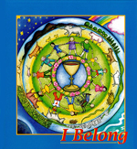
I Belong
Aileen Urquhart ..... ISBN 9780852311714
A programme for parents and children that includes themes, such as parenthood, mercy and glory, drawn from the celebration of Communion and firmly rooted in everyday experience. The programme includes aleader's guide, parent's guide and children's workbook.

I Belong Special
Aileen Urquhart ..... ISBN 9780852312377
This edition of I Belong provides both Makaton signs and simplified language for children with learning difficulties. Each aspect matches the standard book, thereby offering inclusivity for all children in the parish as they prepare for Holy Communion.

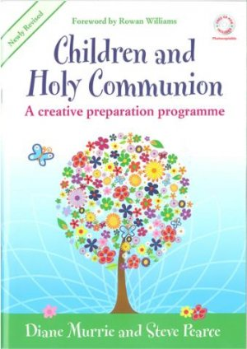
Children and Holy Communion
Pearce & Murrie ..... ISBN 978-1-84417-151-4
A creative preparation programme for preparing the church and the child for Holy Communion, also includes CD Rom.

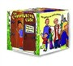
The Communion Cube
Diana Murrie & Margaret Withers
A child-friendly illustrated cube summarising the parts of the Communion service for younger children

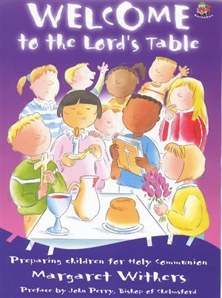
Welcome to the Lord’s Table
Margaret Withers ... ISBN 9781841010434
This is a teaching manual for all those seeking to welcome children to participate fully in the Eucharist. The introductory chapters explore the background to the question of preparing young children for Holy Communion, give guidance on preparing the congregation, training leaders and involving the family, and includes a guide to using the course. The material is designed to last approximately three months overall, with the children receiving Holy Communion towards the end of the course. Each unit is divided into two distinct forty-minute sessions and includes aims and objectives, biblical basis, teaching time, focus on the Church, prayer, activities and suggestions for music. A separate do-at-home activity book is available to accompany the main course book.

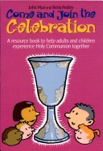
Come and Join the Celebration
John Muir and Betty Pedley ..... ISBN:0715149474
A resource book based on Holy Communion for both adults and children. Chapter titles include; The Liturgy, Helping Younger Children (2 – 6 years old) and Activity Sheets.

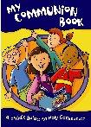
My Communion Book
Diana Murrie ..... ISBN 9780715149461
An all-age resource for children and families, primarily aimed at 4 to 8 year olds. It can be used initially as a sharing book, adult and child reading together, but children may use it at times on their own. Taking the child through the service, the book explains key words and asks questions that relate directly to the child, helping them to engage with the service of Holy Communion.

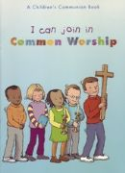
I Can Join in Common Worship
Tony Kershaw ..... ISBN 0 281 05568 8
A Children’s Communion book explaining different elements in common worship.
Colour illustrations combine with the full text of the prayers and explanations of the action giving children the chance to worship God with the whole congregation.
Also available in packs of ten.

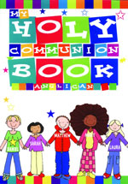
My Holy Communion Book (Anglican)
Aileen Urquhart ..... ISBN 0 85231 238 5
Holy Communion explained for a younger audience, with plastic-coated pages enabling erasing/re-writing of answers.

Celebrating Together
Schofield ..... ISBN 9780719709449
Designed as a resource to encourage churches to work on an all age basis to discover for themselves both the depth and breadth of communion. This is a publication for those interested in exploring the benefits on integrating communion into all-age worship.

Celebrating with Children
Joan Brown ..... ISBN: 1840034815
Ten Roman Catholic liturgical celebrations to use with children who are preparing to receive Communion.
Designed for use in both schools and parishes and to enable children to be involved in a meaningful way.

Meet Christ with Joy: Preparation for Holy Communion
Joan Brown ..... ISBN: 0862091721
A colourful activity book for parents to use with their children as they prepare for first Communion. Through
activities, prayers, Bible stories and celebrations the book aims to relate Mass to everyday experience.

My Eucharistic Journey in Here I Am
Byrne, A. et al ..... ISBN: 0003176711
This book provides worksheets and activities to introduce the themes of Eucharist.

Preparing for First Eucharist
Matthew James ..... ISBN: 1898366284
This resource uses a sensory approach to introduce the Eucharist in fifteen sessions to those with
learning and communication difficulties.

SHARE: A Communion Preparation Course for 7-11's
Nick Harding ..... ISBN: 1840039272
Pre-confirmation. 5 children's sessions including Bible activities, games, prayers & practical ideas. Subjects
covered - God's work, God's word, God's way, God's meal and God's future. + 2 parent sessions

Liturgy for Admission
See Common Worship - Initiation Services
Also, some of the preparation materials above include sample liturgies for the admission of Children to communion.

Children in the Church
John Muir & Betty Pedley ..... ISBN: 0715148850
Practical advice on the involvement of children in all aspects of the communion service and a range of all-
age services.

Bread and Wine People
Susan Sayers ..... ISBN: 184003694X
An all-age programme to enable a whole church approach to exploring the meaning of communion. Relating
to Common Worship it explores the difficulties of an all-age faith community and celebrates the diversity of
such congregations.

Complete Children's Liturgy Book
Katie Thompson ..... ISBN: 0862096367
A comprehensive programme for each Sunday of the lectionary including discussion ideas, activities and
worksheets.

Celebrating Together : Exploring Holy Communion
Kathryn Schofield ..... ISBN: 071970944X
Explores the significance of the meal of Communion and the symbolism of the bread and wine as signs of
God's love. It comprises a structured programme of activities for each age group from under 5's through to
adult.

Admission of Baptised Persons to Holy Communion before Confirmation

Parish Application Form

Parish …………………………………………………………………………………………

Deanery ………………………………………………………………………………………...

Incumbent ………………………………………………………………………………………

Consultation
Has the PCC discussed this subject in the light of the Chelmsford File section: Admission of children to communion before confirmation? Yes No

What was the outcome?

How has the wider congregation been involved in the discussion?

What was the outcome?

Has the diocesan children’s work adviser been approached to advise?

What other guidance or advice has been sought (if any)?

Preparation
How will the preparation of the children for Holy Communion be organised?

Who will lead the preparation, and what training will they be given?

What teaching materials will be used?

How will the children’s nurture towards Confirmation continue after they have been admitted to Holy Communion?

Pastoral Matters
How will parents be involved in the preparation of their children for Holy Communion?

What strategy do you have for families who do not wish for their children to be admitted to Holy Communion?

What strategy do you have for children who come to church without their parents?

What provision will be made for the nurture of children with learning difficulties who wish to receive Holy Communion?

How will children be involved and affirmed as members of the Christian Community:

within the Eucharist?

in non-Eucharistic worship?

in social events?

The admission to Holy Communion Service
It is suggested that ‘first communion’ should be marked in some way appropriate to the life of the parish. Please give information about:

The Service (please attach details)

The Certificate of Admission

The Register

Signed ………………………………....………………(Incumbent) Date …………………………

Please return this form to the Diocesan Children’s Officer

The Old Palace, Deansway, Worcester, WR1 2JE

Thank you

Diocese of Worcester

In the Parish of

..........................................................................................................................

By permission of the Bishop of Worcester
and in accordance with the Holy Communion Regulations 2006

..........................................................................................................................
(name of applicant)

Having been baptised, is admitted to Holy Communion and intends to come to Confirmation at the appropriate time.

..........................................................................................................................
(incumbent’s signature)

..........................................................................................................................
(date)

